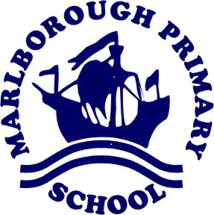
Wednesday 26th February 2020
Dear Parent/Carer,
Advice and guidance – Coronavirus - COVID-19 - NHS England
As I am sure you are aware from today’s news, the situation with Coronavirus is being monitored daily by our government.
As a School and Trust we are regularly checking updates from the Department of Education (DfE), Department of Health, Public Health England and the Foreign and Commonwealth Office.
I recently sent out advice from NHS England, which is included once more through the link below, and further advice below from Public Health England with regards to returning travellers is also included in this communication.
We, like all schools, have been asked to support the government’s campaign by passing on the following information.
You can access the page here: https://www.nhs.uk/conditions/coronavirus-covid-19/
Further Guidance - specified countries and areas with implications for returning travellers or visitors arriving in the UK
Specific advice has now been updated for returning travellers:
https://www.gov.uk/government/publications/covid-19-specified-countries-and-areas/covid-19-specified-countries-and-areas-with-implications-for-returning-travellers-or-visitors-arriving-in-the-uk
If you have recently travelled and returned from the areas listed in the link above, the advice from Public Health England is:
Category 1: Travellers should self-isolate, even if asymptomatic, and call NHS 111 to inform of recent travel.
Category 2: Travellers do not need to undertake any special measures, but if they develop symptoms they should self-isolate and call NHS 111.
What can we all do now?
A UK wide campaign has been launched to provide clear advice on how to slow the spread of Coronavirus. Please reinforce the advice given in this campaign with your son/daughter in that the best way to stop the spread of any virus is to promote basic hygiene practices, such as regularly washing hands and always sneezing into a tissue.
The UK Chief Medical Officers have raised the risk to the public from low to moderate today, but the risk to individuals remains low.
Marlborough Primary Academy remains open as usual, with all events continuing to run as per the calendar. We will continue to follow all NHS England guidance and Local Authority advice, ensuring that the health and wellbeing of all pupils and staff remains a priority.
We will continue to update parents as advised by the UK government accordingly.
Thank you for your support.
Yours sincerely,
Rachel Summers
Headteacher

