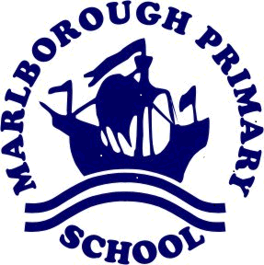
Little Oaks – Newsletter – Autumn term 2 2020
Welcome back after the half term break. The children in Little Oaks will be continuing to learn about Superheroes in English and Topic work. We will be reading a book called Traction Man in English and learning to retell the story. In Topic we will finding out about Florence Nightingale and her inspirational work as a nurse. We will continue to access Outdoor Learning every week – Miss Barrows and Mrs Clouter have some great ideas for our Outdoor area.

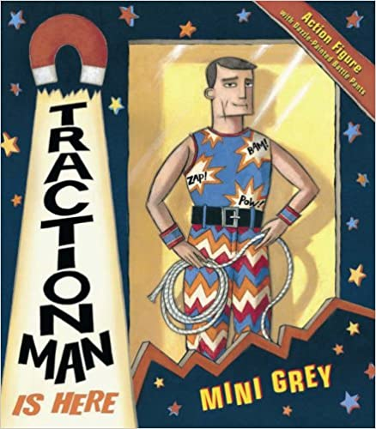

School Uniform
After half term – the children will be having PE on Mondays and Outdoor Learning on Wednesdays. They will need to come in their PE kit or Outdoor Clothes on these days. On the other days, children will need to come in their school uniform: black/ grey trousers/ skirt, a white polo shirt and school jumper or cardigan.
Thank you for viewing the photographs and posting comments on Class Dojo every day. The children experience a broad range of activities every week, inside and outside of the classroom. Please remember to post comments on the Class Dojo as it is great to have parent feedback on the children’s learning.

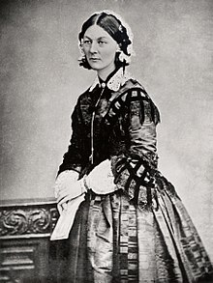
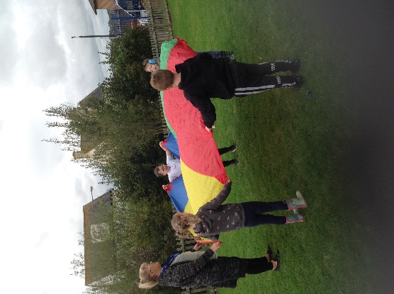
Reading Books
This term, we will be issuing the children with reading books and reading records. Children should be reading at home at least twice a week. This could be learning phonic words which will be sent home or reading their book. Remember to ask the children about Traction Man and his adventures.

Thank you for your support and stay safe.
Mrs Hackworthy , Miss Barrows and Mrs Clouter

