**2M Termly Newsletter**



**Autumn Term Important Dates**

* **Tuesday 3rd- First day back**
* **Wednesday 4th November- Welly Wednesday (weekly)**
* **Monday 9th November- PE (weekly)**
* **Tuesday 10th November- First phonics club for selected pupils**

**Please read our school newsletter to be informed of any upcoming dates.**



**Autumn 2 2020**

**Starts 3rd November – Ends 18th December**

Welcome back! We hope that you have had a great half term. This newsletter will include information about our learning this term as well as a reminder of our routines.

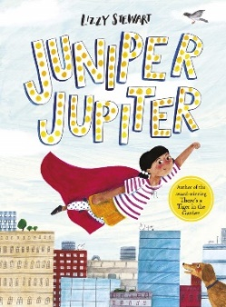 **Our learning this term…**

We will be continuing our topic of Superheroes, including real-life heroes. Our story this term is Juniper Jupiter- she’s a real life superhero!

Near the end of the term we will be getting ready for Christmas with ‘How the Grinch Stole Christmas!’

We will be continuing with Continuous and Enhanced Provision in Year 2 which means that your child will be able to make lots of learning choices for themselves. Helping them to become independent, creative learners.

**Important Reminders**

**Book bags** – It is important for every child to get lots of reading practise in and out of school for them to make good progress. We ask that you write a comment in your child’s **yellow reading record** each time they have read, and ensure that this is brought into school in their book bag with their reading book **every day**. Once they have filled a page in their record, they will earn extra dojos with our home reading challenge (Dojos = prizes!).

**Welly Wednesday-** Each Wednesday afternoon we will do Outdoor Learning. On this day children are required to **come to school** in appropriate clothing. This includes **old, warm clothes** that they are able to get muddy, a **waterproof coat** and **wellington boots.** Please leave wellies in school so that children can change them after each session.

**PE** – Our PE day is on a **Monday**. Due to COVID 19 your child won’t be able to get changed in school so must arrive in their PE kit. They can wear trainers and a tracksuit or jogging bottoms and a sweatshirt in order to be warm on colder days.

**Homework and spellings –** Weekly home tasks will be set through Class Dojo. You can upload these to your child’s portfolio.

**Film Friday-** Each Friday afternoon (during school hours), the children will have the opportunity to buy a ‘Film Friday’ ticket for **50p**. This ticket includes **popcorn** and **juice**. The money that is raised from this club will go towards our classroom resources.

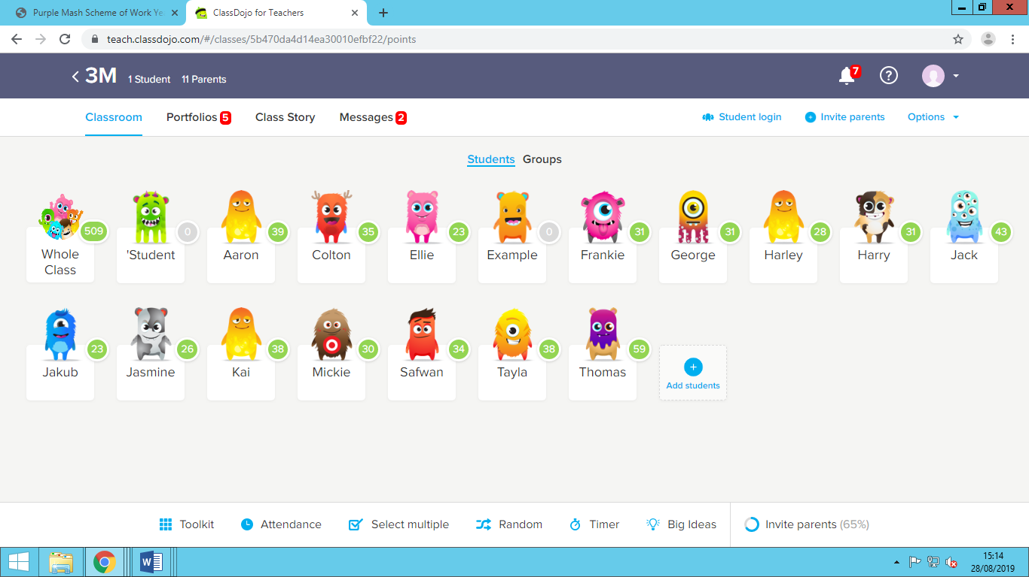**Dojos-** Your child will be rewarded using class dojos. As you know, we also use this to share pictures and group or personal messages with parents/carers. Please see your personalised code and instructions on our separate hand out to download the class dojo app if you haven’t already.

**Phonics club-** Phonics club will take place after school each Tuesday for selected pupils. More details will be included in your child’s individual information letter.

**Recap!**

**Monday –** PE day (arrive in kit)

**Tuesday –** After school Phonics club for **selected pupils**

**Wednesday –** Outdoor learning (arrive in kit with wellies in school)

**Friday -** 50p Film Friday tickets

**DAILY-** Children to bring yellow reading record into school and back home, along with a new book to read.

Thank you again for your support so far this year. It’s been lovely getting to know all of you and our wonderful class. During our first term we would have usually have had meetings face-to-face to catch up on your child’s progress. As we are unable to do this, I hope to speak with you soon with the help of technology!

If you have any questions please speak to me at our bubble entrance or send a message on Class Dojo.

Yours sincerely,

Miss Millar and Ms Totterdell

*The Year 2 Team*