Marvellous Me (7 weeks)
Rationale of the Project
This project was chosen to support children with settling into the new rules and routines of school and encourages them to make new friends and feel confident in their new class. It teaches children about being helpful and kind and how people in their family and school are important.
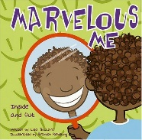
PLOD/Enquiry
- What makes me special?
- What makes my family special?
- Who is in my family tree?
- What is it like where I live?
- Are all homes the same?
Lead Area: Personal, Social and Emotional Development  Development Matters  - Develop their sense of responsibility and membership of a community. (3&4)  - Become more outgoing with unfamiliar people, in the safe context of their setting. (3&4)  - Show more confidence in new social situations (3&4)  - Play with one or more other children, extending and elaborating play ideas. (3&4)  - Increasingly follow rules, understanding why they are important. (3&4)  - Talk about their feelings using words like ‘happy’, ‘sad’, ‘angry’ or ‘worried’. (3&4)  - Build constructive and respectful relationships. (R)  - Identify and moderate their own feelings socially and emotionally. (R) |  |  |  | Lead Area: Personal, Social and Emotional Development  Marlborough EYFS Term by Term Overview  - To understand the importance of sharing and taking turns.  - To show an interest in others play and demonstrate friendly behaviour.  - To grow confident to try new activities.  - To show understanding of rules, know right from wrong and try to behave accordingly.  - To understands consequences to their behaviour.  - To enjoy taking responsibilities  - To form good relationships and including others in their play.  - To show confidence in asking adults for help.  - To form positive attachments to adults and friendships with peers.  - To say follow and respond to new lesson routines, (1,2,3) (see School’s Behaviour Curriculum)
COEL - Playing and Exploring  Engagement  Finding out and exploring  Showing curiosity about objects, events and people  Using senses to explore the world around them  Engaging in open-ended activity  Showing particular interests  Playing with what they know  Pretending objects are things from their experience |  |  |  |  | Representing their experiences in play  Taking on a role in their play  Acting out experiences with other people  Being willing to have a go  Initiating activities  Seeking challenge  Showing a ‘can do’ attitude  Taking a risk, engaging in new experiences, and learning by trial and error
Hook  Pyjama party  Transitions events |  | Ways to engage parents this term  Parents evening  RWI information session  Newsletters  Weekly update on Dojo – Photos of this week’s learning. | Assessment  Baseline assessments and gap analysis:  Pencil grip & stages of drawing evaluation. (see separate docs).  Adapt curriculum after observations and plan groups and individual next steps.  Termly phonics + interventions from week 5 |  |  | Outcomes by end of this term  Children will develop independence – separating from parents, finding peg, self-registration, choosing own areas to work in rather than just following others, tidying up areas where they have worked. They will follow the school rules.
Texts and  Vocabulary | Books  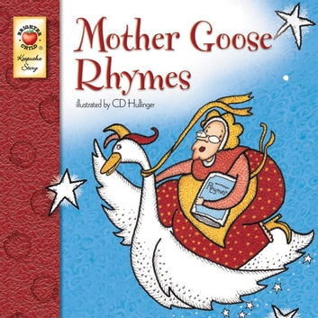  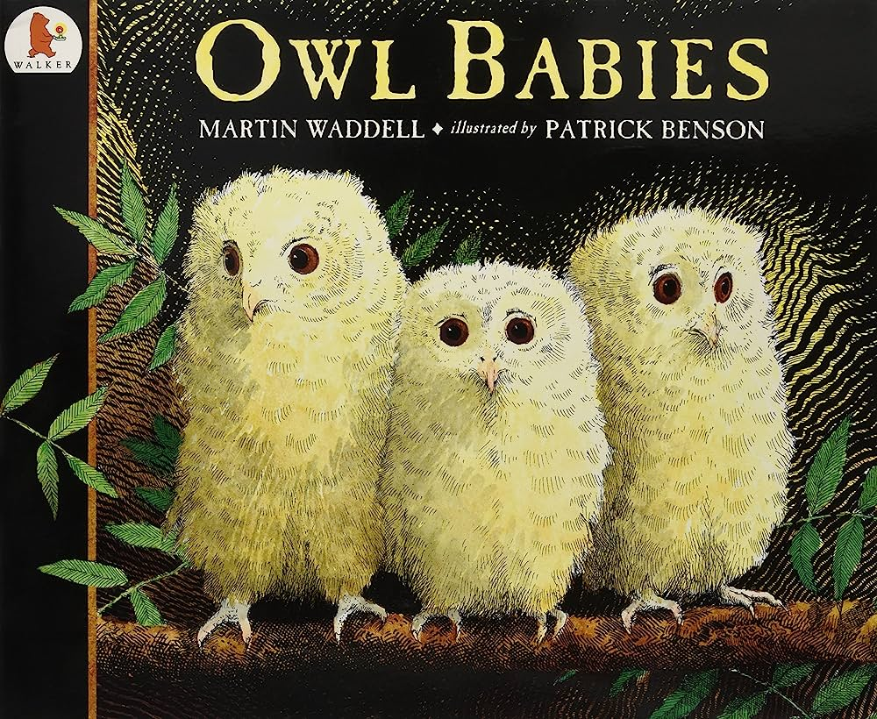  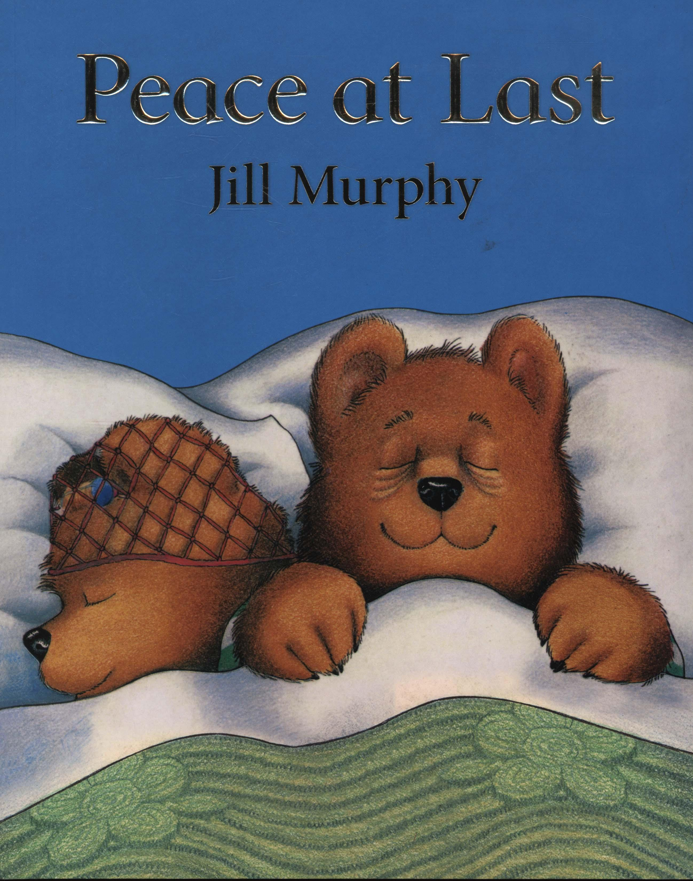  Peace at Last Owl Babies Mother Goose Rhyme  Vocabulary - register, silence, behaviour, line-up, phonics, rules, sad, happy, delighted, worried, angry, rules, respect, calm, tittle, author, hunting, silent, fuss, bounced, swooped, brave, flapped. at last’, hour, tired, nocturnal, pretending, cuckoo, leaky, refrigerator, believe, owl, ivy, hedgehog, uncomfortable, peeped, alarm, clock, yawn, cellar skeleton fed up, nimble, candlestick, fiddle, sport, tuffet, curds and whey.  Other Books end of Day or in the Provision  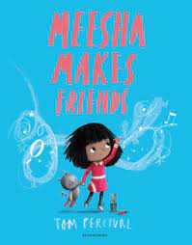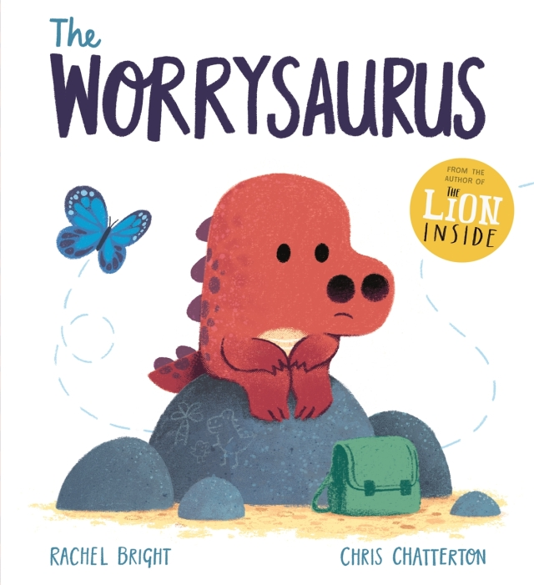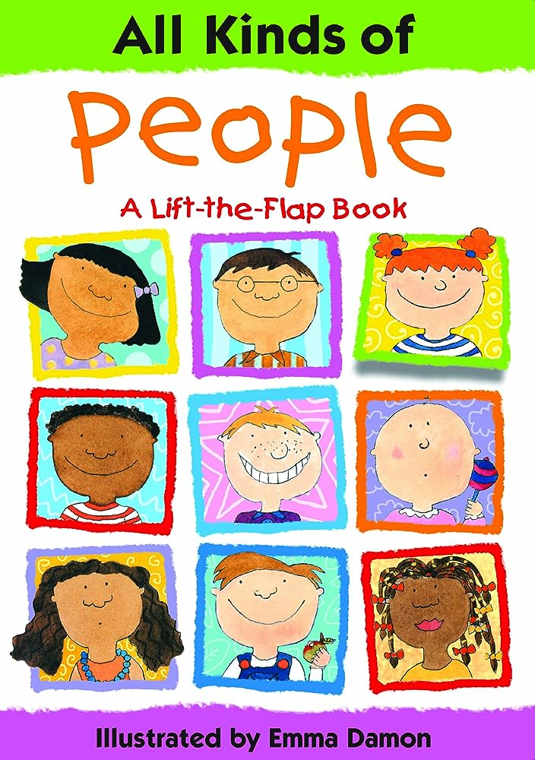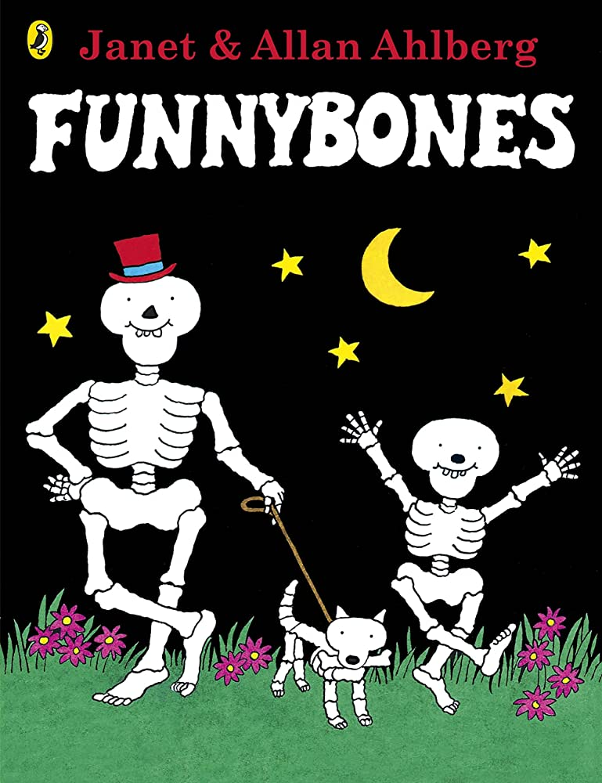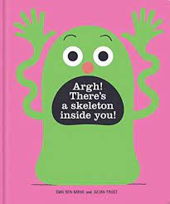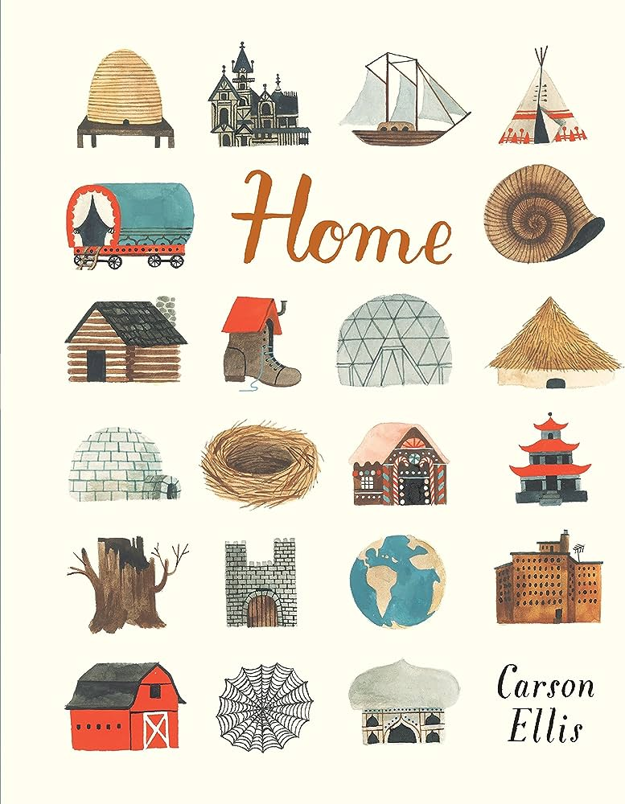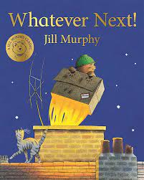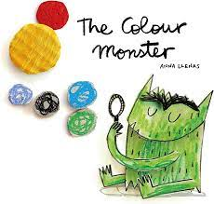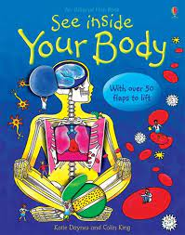

Development Matters |  | Physical Development |  | Communication and Language |  | Literacy |  | Maths |  | Understanding the World |  | Expressive Arts and Design
 |  | Use a comfortable grip with good control when holding pens and pencils. (3&4)  Show a preference for a dominant hand. (3&4)  Develop their small motor skills so that they can use a range of tools competently, safely and confidently. Suggested tools: pencils for drawing and writing, paintbrushes, scissors, knives, forks and spoons. (R)  Further develop the skills they need to manage the school day successfully: lining up and queuing mealtimes (R)  “Before teaching children the correct pencil grip and posture for writing, or how to use a knife and fork and cut with scissors, check:  • that children have developed their upper arm and shoulder strength sufficiently: they do not need to move their shoulders as they move their hands and fingers.  • that they can move and rotate their lower arms and wrists independently.” |  | Understand a question or instruction that has two parts, such as: “Get your coat and wait at the door”. (3&4)  Understand ‘why’ questions, like: “Why do you think the caterpillar got so fat?” (3&4)  Understand how to listen carefully and why listening is important. (R) |  | Write some or all of letters in their name. (3&4  Write some letters accurately. (3&4) |  | Develop fast recognition of up to 3 objects, without having to count them individually (‘subitising’). (3&4)  Talk about and explore 2D and 3D shapes (for example, circles, rectangles, triangles and cuboids) using informal and mathematical language: ‘sides’, ‘corners’; ‘straight’, ‘flat’, ‘round’ . (3&4)  Recite numbers past 5. (3&4)  Complete inset puzzles.  (0 -3Y)  Notice patterns and arrange things in patterns. (3&4) |  | Begin to make sense of their own life-story and family’s history. (3&4)  Talk about members of their immediate family and community. (R)  Name and describe people who are familiar to them. (R)  Draw information from a simple map. (R) |  | Make imaginative and complex ‘small worlds’ with blocks and construction kits, such as a city with different buildings and a park. (3&4)  Begin to develop complex stories using small world equipment like animal sets, dolls and dolls houses, etc. (3&4)  Create closed shapes with continuous lines and  begin to use these shapes to represent objects. (3&4)  Draw with increasing complexity and detail, such as representing a face with a circle and including details. (3&4)  Use drawing to represent ideas(3&4)  Explore colour and colour mixing. (3&4)  Show different emotions in their drawings, like happiness, sadness, fear, etc. (3&4)  Create collaboratively, sharing ideas, resources and skills. (R)
Week 1  x 3 days | Learning  EYFS Term by Term Overview |  | Physical Development |  | Communication and Language |  | Literacy |  | Maths |  | Understanding the World |  | Expressive Arts and Design
 |  |  | To move freely using suitable spaces and speed. |  | To follow simple instructions.  To listen and respond to stories. |  | To recognise letters in their name.  To copy some letters from their name.  To identify title in a book. |  | To match objects  To sing counting songs |  | To think about periods of the day |  | To learn and sing new songs.
 | Outcome  & possible activities |  | Children explore different areas of the indoor and outdoor classrooms.  Play-dough dance. |  | Children will start to join in when reading stories, singing or chanting.  Children will respond to instructions, such as put your coat on and go outside. |  | Pupils will be able to find their names and copy some letters.  Pupils will be able to point at the tittle in a book. |  | Children will be able to match objects such as socks, bottles to tops, etc. |  | Children will understand different times of the day such as carpet time, home time, lunchtime, story time. |  | Pupils will be able join in when o sings songs and rhymes.  Take part in ‘Rhyme Time and music lessons.
 | Texts |  | Core book: Owl Babies  End of Day: Starting school, Colour Monster; Colour Monster Starts School; Fantastic First Poems.

Week 2  5 days | Learning  EYFS Term by Term Overview | Physical Development | Communication and Language | Literacy | Maths | Understanding the World | Expressive Arts and Design
 |  | To use a fork and spoon at lunchtimes.  To put on own coats & and attempt fastenings.  To pull off jumpers and cardigans with increasing independence.  To draw lines and circles. | To learn listening skills  To join in with rhymes, rhythms and refrains.  To listen and respond to stories.  To look at picture books.  To follow two-part instructions.  To join in with key events and phrases in a retelling of the story | To identify title in a book.  To listen and identify sounds in the environments.  See phonics Long Term Plan for sounds to be taught this week. | To match objects  To match pictures and objects | To understand that class rules are there to keep everyone happy and safe.  To think about periods of the day.  To become familiar with new school surroundings. | To learn and sing new songs.  To take part in pretend play, using objects to represent something else.
 | Outcome  & possible activities | Children will take active part in play-dough dance and finger gym activities.  Pencil grip assessment  (see chart /separate doc) | Children will join in with repeated phrases from the story.  Pupils will listen to stories with increasing attention.  Children will act out the story.  Children will look at books and use the book corner independently.  Children develop social phrases. | Copy name from a name card.  Daily RWI Lessons | Children will recite numbers in the morning to check how many children are in the class, sing number song and count some objects when tiding up.  Match by size, colour, shapes. | Children will understand different times of the day such as carpet time, home time, lunch time, story time. | Children will join in pretend play, negotiate roles and sort out conflicts with some adult support.  Draw pictures of themselves and others.
 | Texts | Core book – Owl Babies,  End of day/: Marvellous Me, Meesha Makes Friends, Worrysauros, I like Bees I don’t like Honey! All Kinds of People.

Week 3 | Learning  EYFS Term by Term Overview | Physical Development | Communication and Language | Literacy | Maths | Understanding the World | Expressive Arts and Design
 |  | To explore and use simple tools for an outcome e.g., scissors, small tap hammers, etc.  To pull off jumpers and cardigans with increasing independence.  To develop skills to move mark making tools from top to bottom.  To put wellies on.  Weekly PE lessons start. | To learn listening skills  To join in with rhymes, rhythms and refrains.  To listen and respond to stories.  To look at picture books.  To follow two-part instructions. | To understand that letter(s) on the page symbolise spoken sounds in words.  To attempt to forms letters appropriately and write their name.  See phonics Long Term Plan for sounds to be taught this week.  To recognise characters in a book.  To listen to and say initial sounds in words. | To Match objects and pictures.  To identify a set.  To sort objects to a type.  To explore sorting techniques. | To know the names of different body parts.  To use a timeline to recall the passage of time.  To make healthy choices about food, drink, activity and teeth brushing.  We will play “Simon Says”, emphasising names of body parts. | Play instruments with increasing control to express their feelings and ideas.  To take part in pretend play, using objects to represent something else.  To explore portraits.
 | Outcome  & possible activities | Children access gross and fine activities available both indoor and outdoor.  Children develop independence to put coats, jumpers and wellies on and off independently. | Children will join in with repeated phrases from the story.  Pupils will listen to stories with increasing attention.  Children will act out the story.  Children will look at books and use the book corner independently | Copy name from a name card.  Forms some letters accurately, particularly the ones in their name.  Children start to hear initial sound when playing games and completing activities such as Silly Soup. | Children will sort and group objects by their attributes. For example, toys, buttons, boys, girls, etc. | Children will use the visual timetable.  Name parts of the body.  Look at books and ask questions about their bodies.  Activities such: brush teddy’s/ dolls teeth. | Children will confidently explore instruments available in the provision.  We will enhance the environment so children can stick and attach.
 | Texts | Core Book- Mother Goose  End of Day: Funnybones, Owl Babies, Inside your Body (non-fiction); There is a Skeleton Inside; All Kinds of People, What makes me a me?  Ravis’ Roar.

Week 4 | Learning  EYFS Term by Term Overview | Physical Development | Communication and Language | Literacy | Maths | Understanding the World | Expressive Arts and Design
 |  | To use pincer movements to thread & peg.  To develop accuracy and dexterity to use small tap hammers.  To develop skills to move mark making tools from top to bottom. | To increase the ability to listen in guided activities.  To join in with rhymes, rhythms and refrains.  To listen and respond to stories.  To follow two-part instructions. | To identify title in a book.  To identify characters in a story.  To listen and identify sounds in the environments.  To add some marks to their drawings, which they give meaning to e.g. “That says mummy”.  To enjoy drawing freely.  To make marks on their picture to stand for their name.  See phonics Long Term Plan for sounds to be taught this week. | To explore sorting techniques.  To create sorting rules.  To compare amounts.  Mastering number week One –  To identify when a set can be subitised and  when counting is needed. | To name and describe people who are familiar to them.  Talk about members of my immediate family.  Start weekly cooking sessions. | To draw with increasing complexity and detail,  such as representing a face with a circle and  including details.  To show emotions in their drawings and  Paintings, e.g., happiness, sadness, fear, etc.  To explore colour mixing.
 | Outcome  & possible activities | Children will use the outdoor and indoor spaces to move.  Engage in all the finger gym activities. | Children will learn listen and use the vocabulary, particularly when modelled and reminded by an adult.  Use sentences of four to six words with more confidence.  Enjoy singing and chanting new songs and rhymes.  Adults will share books which encourage children to look closely at  the pictures.  To use descriptive vocabulary and to discuss with others as objects are found or cannot be seen. | When reading to children, sensitively draw their attention to the parts of the books.  We will:  Show children how to handle books and to turn the pages one at a time.  Show children where the text is, and how English print is read left to right and top to bottom.  Show children how sentences start with capital letters and end with full stops. Explain the idea of a ‘word’ to children, pointing out how some words are longer than others and how there is always a space before and after a word. Page 79-80 Dev. Matters | Children will become familiar with school resources.  Children will sort objects and mathematical resources and create their own sorting rules buttons. | Children will be talking about photos and memories.  They will be able to share pictures of their family and retell what their parents told them about their life-story and family. | Children will be able to use mirror to attempt to draw self-portraits and portraits of their families and friends.
 | Texts | Core Book- Peace at Last  End of Day: Whatever Next -JM; Owl Babies; All Kinds of families; A little bit Brave; All Kinds of Families; Once there Were Giants; The Same but Different Too.

Week 5 | Learning  EYFS Term by Term Overview | Physical Development | Communication and Language | Literacy | Maths | Understanding the World | Expressive Arts and Design
 |  | To develop skills to move mark making tools from top to bottom.  To use anticlockwise movements.  To draw circles. | To learn listening skills.  To join in with rhymes, rhythms and refrains.  To listen and respond to stories.  To look at picture books  To start a conversation with an adult or peers. | To identify title in a book.  To listen and identify sounds in the environments.  To head initial sounds in words.  See phonics Long Term Plan for sounds to be taught this week. | To compare sizes  To compare mass  To compare capacity  Mastering number week two  To identify when a set can be subitised and  when counting is needed | To explore and observe features of our school and local area.  Start weekly Forest School Session – Welly Wednesday. | Listen with increased attention to sounds.  To join different materials and explore different textures.
 | Outcome  & possible activities | Use scissors, tweezers, tap hammers, screws, nails, and other resources available in the provision. | Children start to use new language in conversations and play.  Children learn new songs and | Children identify tittle in a book.  Hear initial sound in words.  Retells stories  Draws pictures that retell stories. | Comparing amounts and groups of objects.  Compare size in play and use the correct language. | Children will compare their homes and and familiar local places with those from books and videos.  Local walk - maps | Pupils will use glue and masking tape for sticking pieces of scrap materials onto old cardboard boxes, hammers and nails and paperclips.  Play Sound lotto
 | Texts | Core Book- Peace at Last  End of Day: Home –CE; In Every House on Every Street; The Three Little Pigs; The 3 Horrid Little Pigs; A new House for A Mouse

Week 6 | Learning  EYFS Term by Term Overview | Physical Development | Communication and Language | Literacy | Maths | Understanding the World | Expressive Arts and Design
 |  | To develop skills to move mark making tools from top to bottom.  To use anticlockwise movements to draw circles.  To use pincer movements to thread & peg.  To cross the middle line. | To learn listening skills  To join in with rhymes, rhythms and refrains.  To listen and respond to stories.  To look at picture books.  Begin to understand how to listen carefully and why listening is important.  Engage in story times.  Learn new vocabulary Articulate their ideas and thoughts. | To identify title in a book.  To listen and identify sounds in the environments.  To learn rhymes  To head initial sounds in words.  See phonics Long Term Plan for sounds to be taught this week. | To explore simple patterns.  To copy and continue simple patterns.  To create simple patterns  Mastering number week three.  To subitise different arrangements, both  unstructured and structured, including using the Hungarian number frame. | To developing positive attitudes about the differences between people.  To explore and observe features of our school and local area. | To create structures and models using a variety of resources. For example, tapes, scissors, glue, etc.  Children will be able draw and paint portraits their families and friends.
 | Outcome  & possible activities | Pupils will be able to threads, use hole punchers, draw circles and lines. | Describe events in some detail. | Recite rhymes and use them to build a narrative.  Orally blend familiar words.  Orally retells known rhymes and stories. | Follows patterns using shapes or other objects.  Continues a pictorial pattern. | Children will compare their homes and and familiar local places with those from books and videos.  We will look at aerial views of the school setting, encouraging children to comment on what they notice.  Draw simple maps. | Make models of their homes or school.  Teach children different techniques for joining materials, such as how to use adhesive tape and different sorts of glue.
 | Texts | Core Book- Peace at Last  End of Day: Home –CE; In Every House on Every Street; Whatever Next; A new House for A Mouse; Build a House

Week 7 | Learning  EYFS Term by Term Overview | Physical Development | Communication and Language | Literacy | Maths | Understanding the World | Expressive Arts and Design
 |  | To develop skills to move mark making tools from top to bottom.  To use anticlockwise movements to draw circles.  To use pincer movements to thread & peg.  To cross the ‘di-line’ of the bodies. | To learn listening skills  To join in with rhymes, rhythms and refrains.  To listen and respond to stories.  To look at picture books. | To identify title in a book.  To listen and identify sounds in the environments.  To head initial sounds in words.  See phonics Long Term Plan for sounds to be taught this week. | To find 1, 2 and 3  To subitise up 3  To represent 1,2 and 3  Mastering number week four.  To subitise different arrangements, both  unstructured and structured, including using the Hungarian number frame | To develop positive attitudes about the differences between people.  To explore and observe features of our school and local area. | To create structures and models using a variety of resources. For example, tapes, scissors, glue, etc.
 | Outcome  & possible activities | Children will use equipment such as tap-a-shape, geoboards,  Join play-dough dance.  Paint without changing hand | Ask children about their home.  Role play area - home and encourage descriptive and imaginative language.  Maps of local area | Children identify tittle in a book.  Hear initial sound in words.  Retells stories  Draws pictures  Orally blend familiar words. | Subitise up to 3 objects – Hungarian pattern or sometimes different arrangements.  Represent numbers using objects or marks | Walk around the local area.  Children will be familiar with name of our local area and the  school.  We will look at aerial views of the school setting, encouraging children to comment on what they notice, recognising buildings, open space and other  simple features. | Make models of their home and other structures from familiar settings.
 | Texts | Core Book- Peace at Last  End of Day: Home –CE; In Every House on Every Street; The Three Little Pigs; The 3 Horrid Little Pigs; The Same but Different Too

