https://www.teachyourmonstertoread.com/

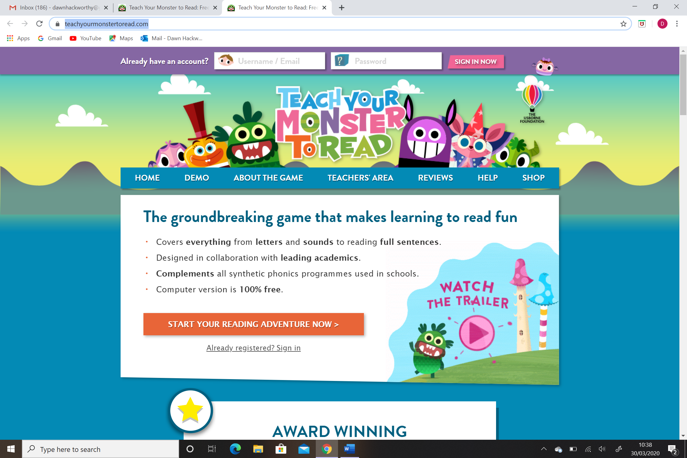

https://www.scratchjr.org/
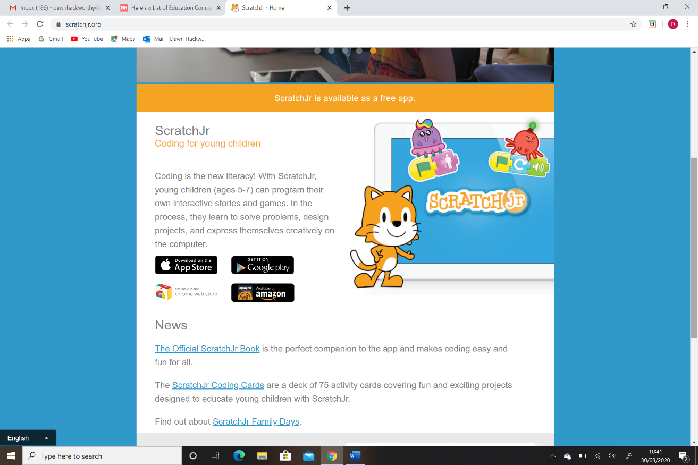

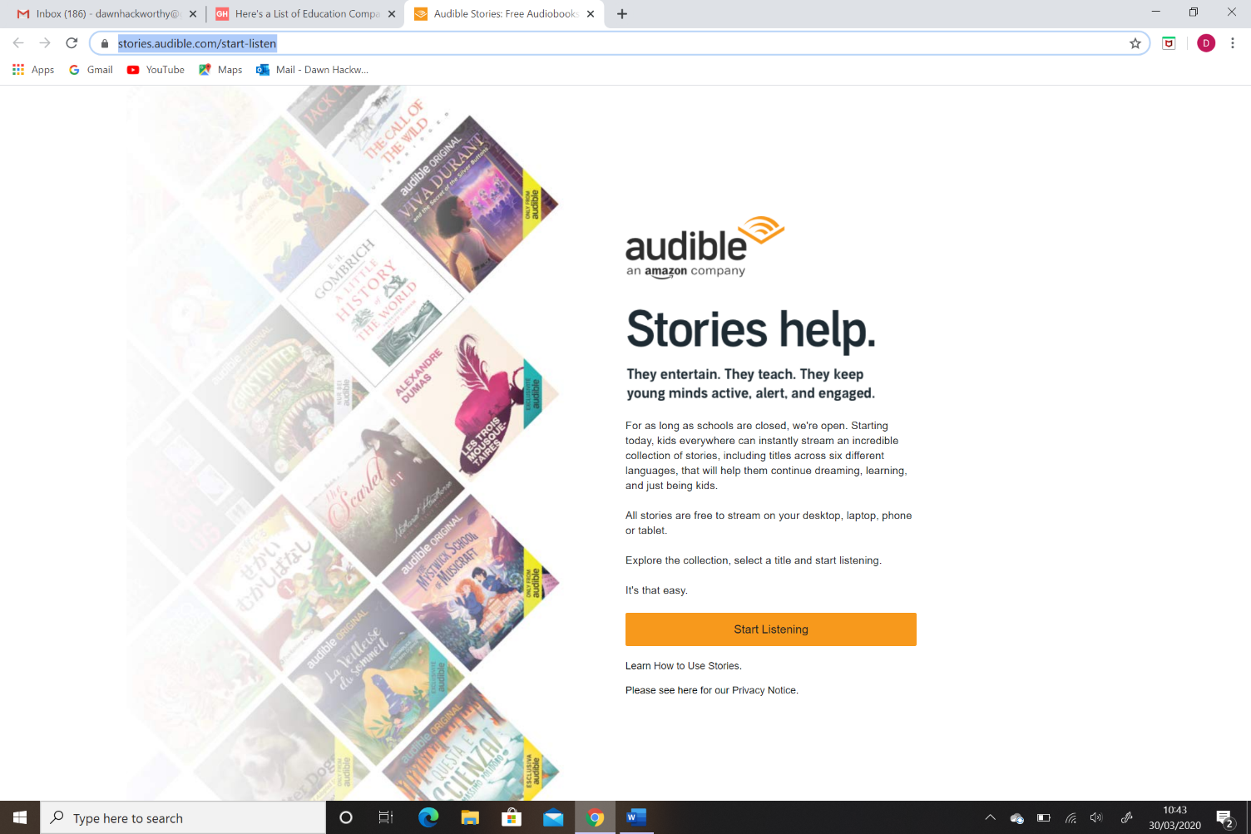
https://stories.audible.com/start-listen

https://www.gonoodle.com/for-families/
